Goal: Predict users next order
Sample contains 3 million grocery orders from more than 200,000 users. Out of every user, order 4 to 100 are given. The last order of a user has been removed and divided into train and test sets hence why there are so many data sets. Prior order information is present in order_products_prior file. A column in orders.csv titled eval_set informs which three data set in given row goes to.

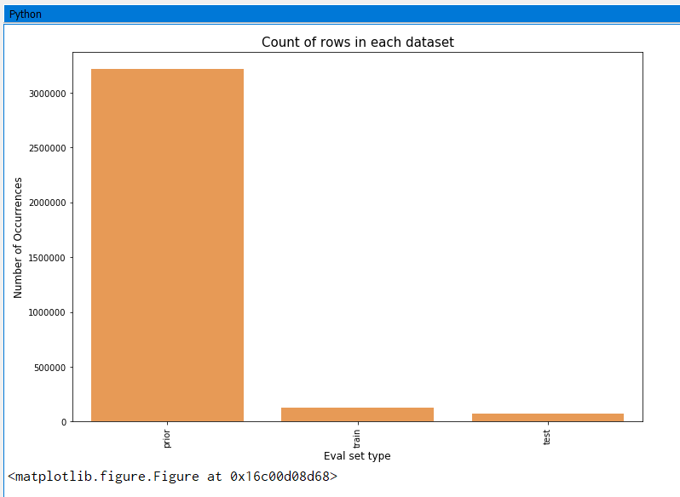
Count of rows in each data set.
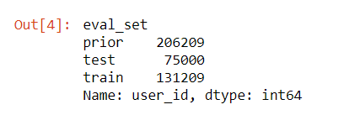
206209 total customers. 131209 are given as train set, 75000 are what is to be predicted.

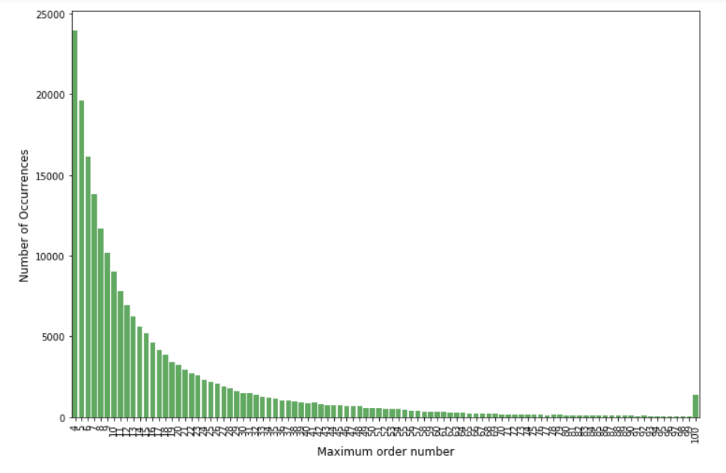
No orders less than 4 or greater than 100 as stated earlier.
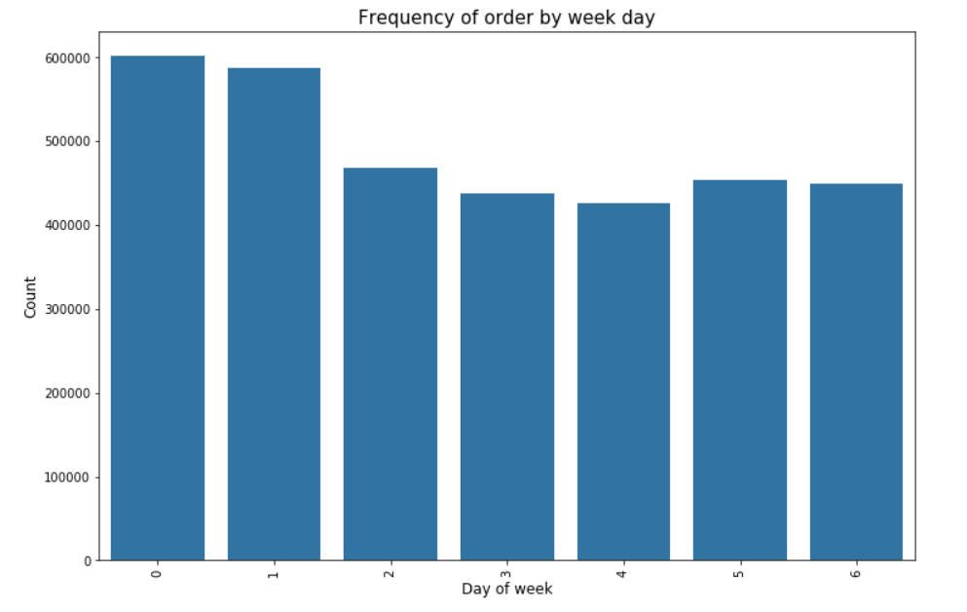
0 and 1 would be the weekend being higher purchase rates. Midweek orders are much lower.
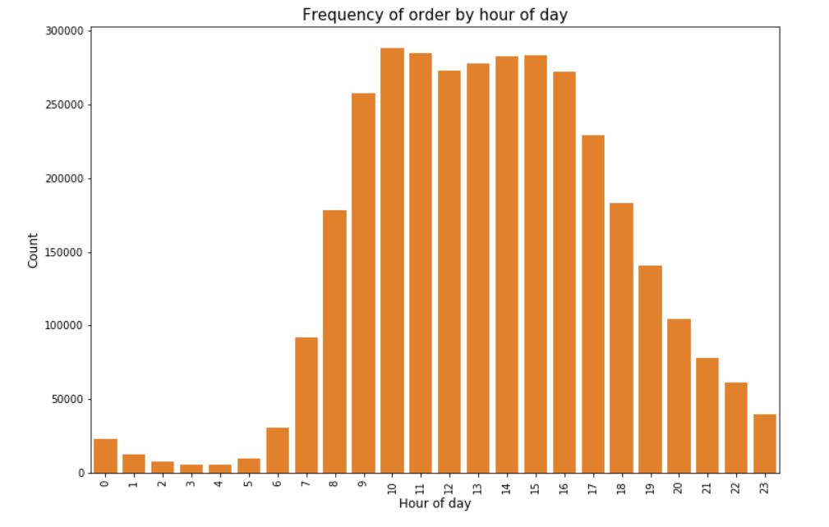
Orders are placed most frequently between hour 10 and 16. We can assume this to be daytime hours.

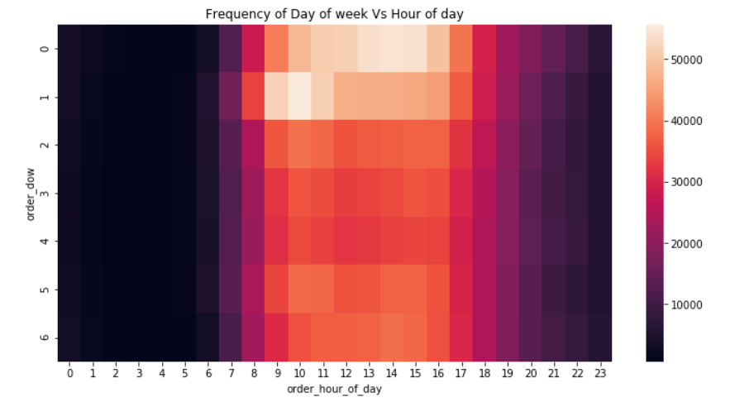
Again, the weekend Saturday night and Sunday morning shows the most frequent time for orders.

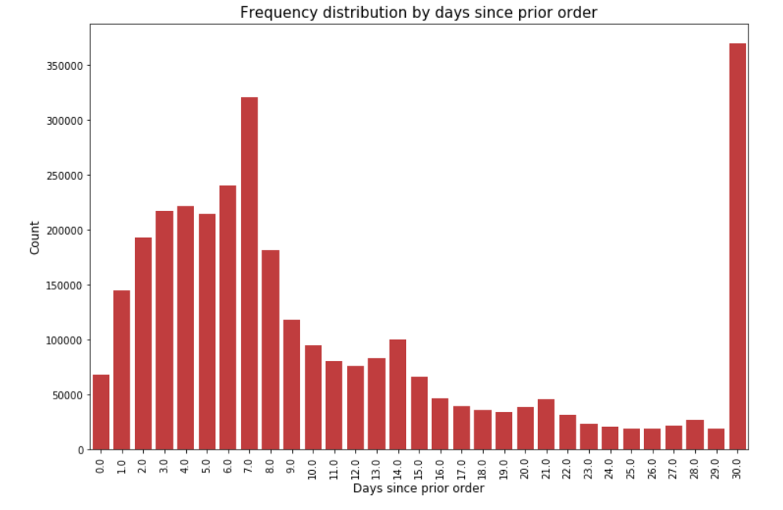
The peaks at 7 may indicate customers order in once a week or possibly once a month with the peak at 30.
Percentage of re-orders in prior data set
Percentage of re-orders in train set.
Conclusion: Average is 59% that orders being ordered are in fact re-orders.
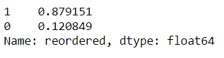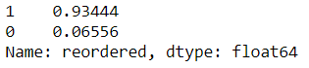
12% orders are no re-orders in prior data set.
6.5% orders are no re-orders in train data set.
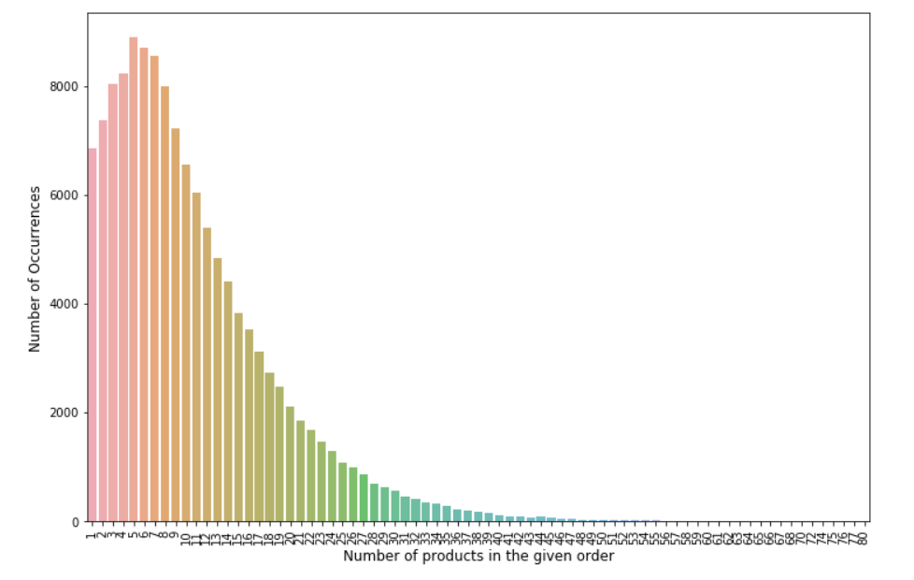
Number of products bought in each order. Highest value at 5 with a right tail distribution.
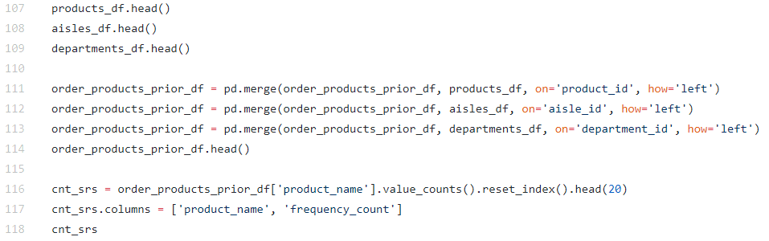
Syntax above showcases the product details files with the order prior data set.
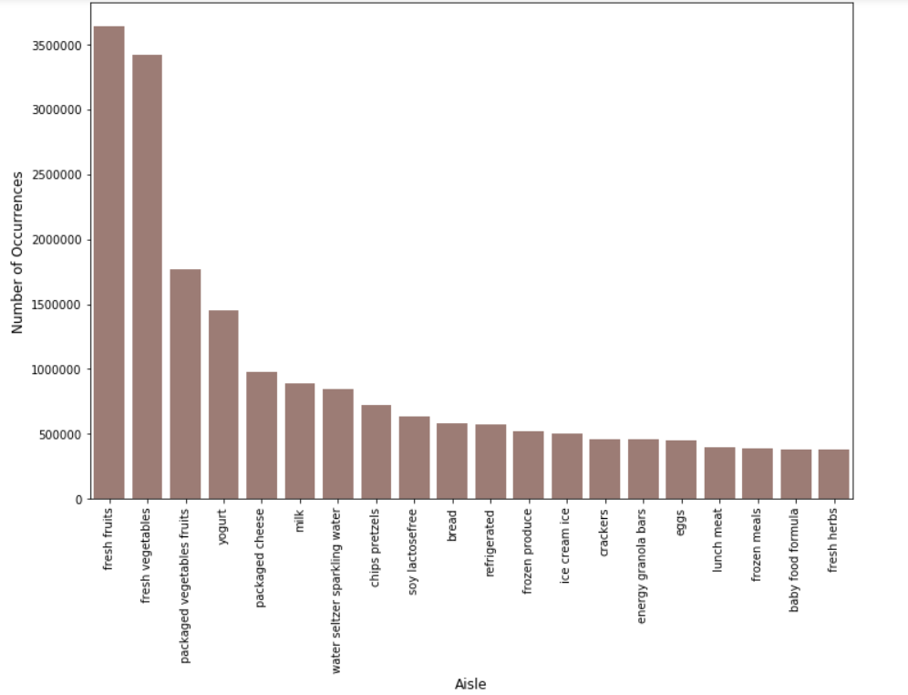
The top selling items in aisles include fresh fruits and fresh vegetables.
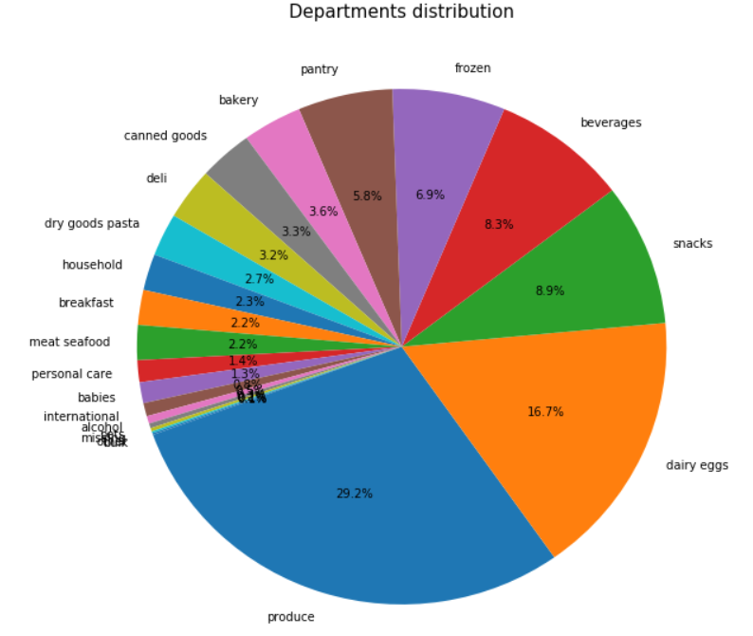
Produce is the largest department.
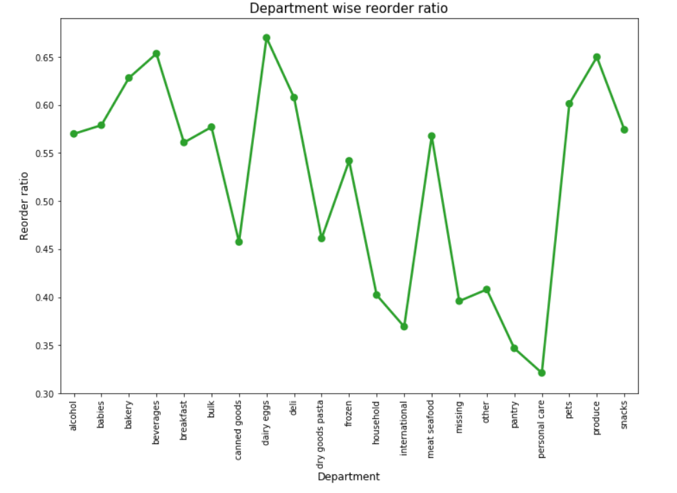
Dairy eggs have the highest re-order ratio and personal care has the lowest.
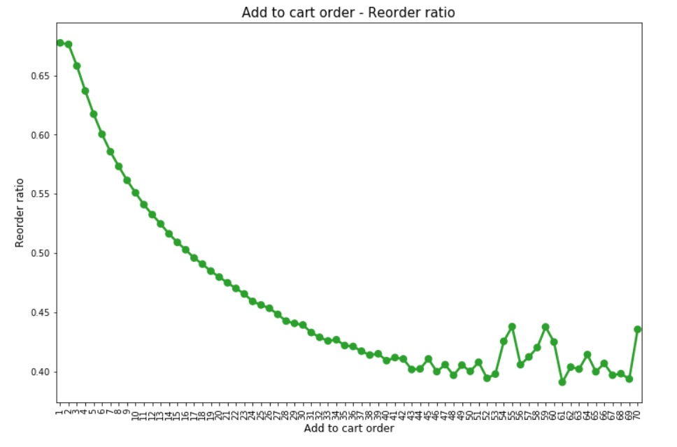
Products added to cart first are most likely to be re-ordered again.
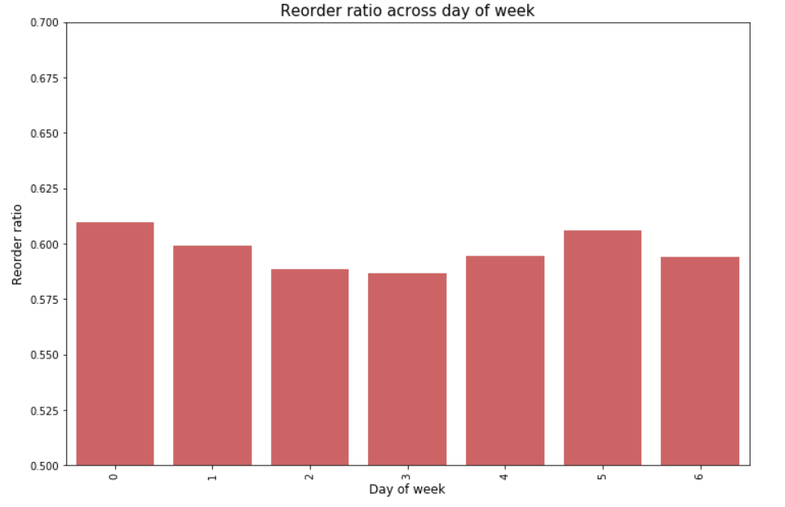
Re-order ratio based on day of week is higher for the weekend 0 and 1.
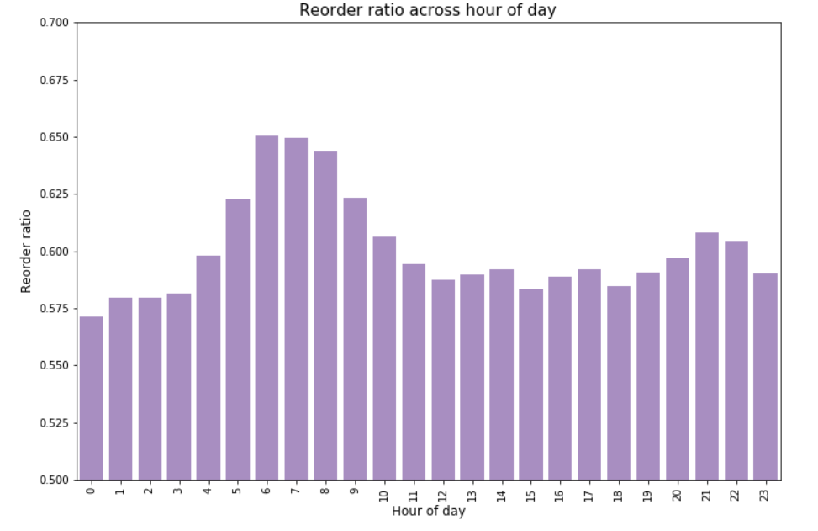
Re-order ratio broke down into hours indicates hour 5 through 9 have the highest ratio.

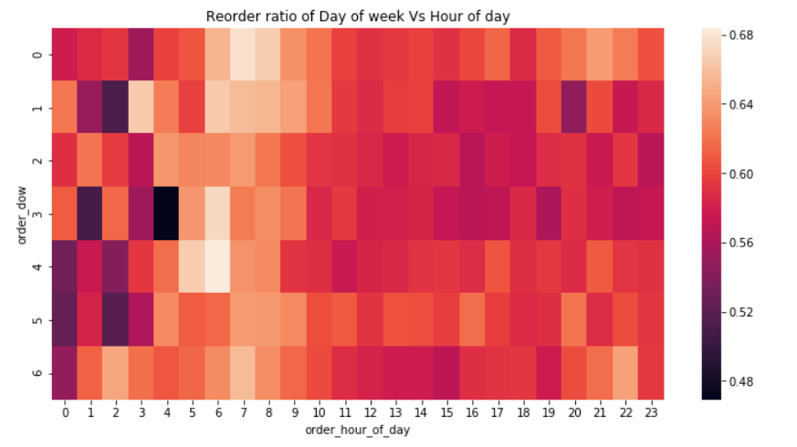
Re-orders are more common earlier in the day than later.

